LIFESTYLE WEIGHT TRACKER

Dataset name: lifestyle weight tracker.csv
Problem Statement:
find the weight by using daily routines.
Dataset Size:
(55000, 18)
It contains 55000 rows and 18 columns.
Feature name and types:
# Column Dtype
--- ------ --------------
0 User_ID int64
1 Age int64
2 Gender object
3 Height_cm float64
4 Initial_Weight_kg float64
5 Stress_Level int64
6 Sleep_Hours float64
7 Caffeine_mg float64
8 Calories_Consumed float64
9 Protein_g float64
10 Carbs_g float64
11 Fat_g float64
12 Steps int64
13 Workout_Type object
14 Workout_Intensity int64
15 Temp_C float64
16 Weight_Change float64
17 Current_Weight_kg float64

Null values:
There are 2750 null values in Calories_Consumed column.
There are 27552 null values in Workout_Type.
Outliers:
There are outliers in Calories_Consumed, Protein_g, Carbs_g, Fat_g columns.
Loading the dataset:
1. Load the dataset
df=pd. read_ csv ("lifestyle weight tracker.csv")
2.understanding the dataset:
Dataset head (), tail (), info (), describe (), isnull (), duplicated (), shape
Data cleaning process:
1. Calories_Consumed have null values and outliers so we replace those null values with medium.
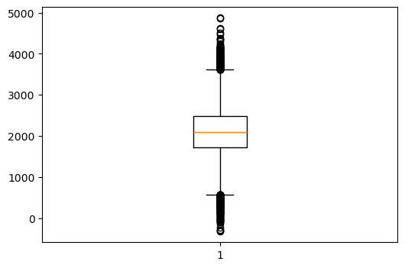

2. Workout_Type have null values and as it is object datatype, replaced those null values with mode.
3.To remove the outliers, performed Q1, Q2, IQR and treated the outliers.
EDA after data cleaning:
1.Plotted the box plots for the outlier detected columns to check whether outliers are treated or not.
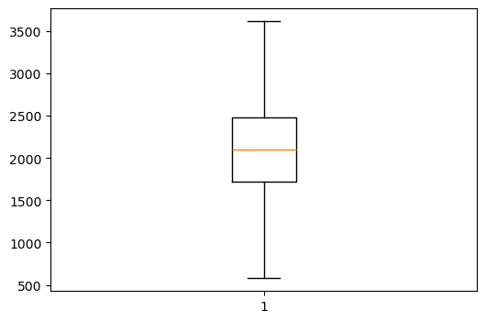

Feature Selection:
1. Selected the features based on the correlation with target feature.
2.Selected the strong related columns.
3.The reason for performing correlation is that there are many features out of many to select only the important and related features. So that the result will be accurate.
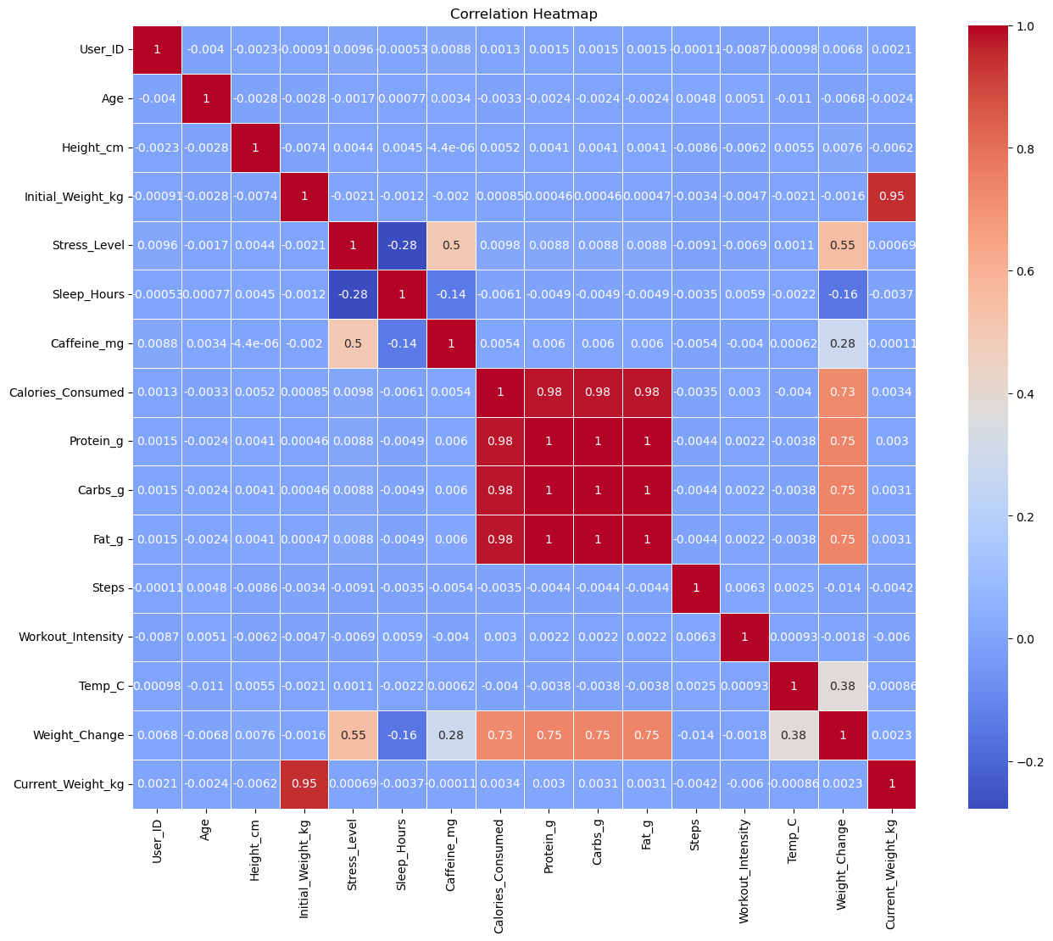

Data Partition:
1.It is performed to separate the training and testing size.
Train_size=80
Test_size=20
Data transformation:
1.Conducted StandardScaler on the X columns. As the features are continuous.
Model selection:
1.selected the LinearRegression () model as the target variable is numeric.
Model Performance:
1.Hold partition:
train MAE: 0.03201214628156866
test MAE: 0.03172198859911002
train MSE: 0.0016095099106854765
test MSE: 0.0015804737479168678
train RMSE: 0.040118697769063696
test RMSE: 0.03975517259322198
train R² Score: 0.8542423132267143
test R² Score: 0.8592018803422306
Training Score: 0.8542423132267143
Testing Score: 0.8592018803422306
Comparing the R^2 score. Both the training and testing are near so the model is stable.
2.Cross validation:
Cross Validation Scores:
[0.85282771 0.85541512 0.85343157 0.85030679 0.85580725 0.86050033
0.85403769 0.85689951 0.85431478 0.8582585]
Mean CV Score: 0.8551799235067132
It is also similar to R62 scores. So model performs well on any partition.
Overfitting/Underfitting:
There is no overfitting / underfitting as the scores are similar.
Saving the final model:
1.Saved the final linear model.
2.Saved the final transformed file.
3.Saved the features names.
Streamlit interface:
1. imported the saved files and coded for web interface.
app.py
